Cybersecurity Analyst Internship
Task Report

[samfelix15@gmail.com]
Task No: [15- Log Analysis]

Copyright © 2024 EncryptEdge Labs. All rights reserved
Credit: Offensive Security

Table of Contents
1.0 EncryptEdge Labs Internship Task Report 2
1.1 Introduction 3
1.2 Objective 3
1.3 Requirements 4
2.0 High-Level Summary 7
2.1 Recommendations 8
2.2 Risk exposure over time 9
3.0 Report - Methodologies 10
3.1 Information Gathering 11
4.0 Additionals Item 13
4.1 Screenshots X
1.0 EncryptEdge Labs Internship Task Report
1.1 Introduction
Log analysis is a critical component of cybersecurity that involves examining log data to identify potential security threats, detect anomalies, and respond to incidents. Logs are records of events that occur within an organization's systems, networks, and applications, providing valuable insights into system activity, user behavior, and potential security incidents. In this report, we will discuss the importance of log analysis in cybersecurity, types of information found in logs, and their relevance in detecting anomalies or security incidents.

1.2 Objective
The objectives of log analysis in cybersecurity are to:
Detect security incidents: Identify potential security incidents, such as unauthorized access attempts, malware infections, or data breaches.
Identify anomalies: Identify unusual patterns of behavior that may indicate potential security threats.
Improve incident response: Provide valuable information for incident response, such as the source of an attack and the scope of the incident.
Enhance security posture: Identify vulnerabilities, weaknesses, and areas for improvement to enhance the organization's security posture.
Based on this report, my objective is to
Develop skills in analyzing log data to identify security-related patterns or suspicious activities.
Learn how to detect and interpret security incidents based on log data.
Develop skills in analyzing log data to identify security-related patterns or suspicious activities.
Develop foundational skills in log analysis and management. Learn how to interpret, analyze, and derive actionable insights from logs using various tools and techniques to enhance security monitoring and incident response.

1.3 Requirements
The requirements for effective log analysis will include the following.
Log collection: Collecting logs from various sources, such as systems, networks, and applications.
Log storage: Storing logs in a secure and centralized location.
Log analysis tools: Using log analysis tools, such as Security Information and Event Management (SIEM) systems, to analyze and visualize log data.
Skilled personnel: Having skilled personnel to analyze and interpret log data.
In reference to my report on log analysis, I am required to,
Submit a report explaining the importance of log analysis in cybersecurity. Include details on types of information found in logs and their relevance for detecting anomalies or security incidents.
Submit screenshots showing the configuration of your log analysis platform and log collection setup from various sources. Include brief descriptions of each source and how logs are forwarded.
Submit screenshots showing examples of your log queries and findings. Describe any patterns or security-related events identified and how these may indicate potential threats.
Submit a report detailing how you detected and correlated events to identify security incidents. Include screenshots of relevant logs and descriptions of the identified security issues.
NB: Tools used my report will include
Log Analysis Tool: ELK Stack (Elasticsearch, Logstash, Kibana) or another tool like Splunk.
Sample Log Files: Provided or sourced from available repositories.
Types of Log Analysis
There are several types of log analysis, including:
1. Security Log Analysis: Focuses on identifying potential security threats, such as unauthorized access attempts, malware infections, or data breaches.
2. Compliance Log Analysis: Focuses on ensuring compliance with regulatory requirements, such as HIPAA or PCI-DSS.
3. Operational Log Analysis: Focuses on identifying operational issues, such as system crashes, network outages, or application errors.
4. Forensic Log Analysis: Focuses on analyzing logs to investigate security incidents or other events.

Types of Information Found in Logs
Logs can contain a wide range of information, including:
System events: Logs can record system events, such as login attempts, file access, and system changes.
Network activity: Logs can record network activity, such as incoming and outgoing traffic, connections, and packets.
Application events: Logs can record application events, such as user activity, errors, and exceptions.
User behavior: Logs can record user behavior, such as login attempts, search queries, and file access.

Relevance of Logs in Detecting Anomalies or Security Incidents
Logs are relevant in detecting anomalies or security incidents because they provide a record of system activity, user behavior, and potential security threats. By analyzing logs, security teams can:
Identify patterns of behavior: Logs can help identify patterns of behavior that may indicate potential security threats.
Detect anomalies :Logs can help detect anomalies that may indicate potential security incidents.
Respond to incidents Logs can provide valuable information for incident response, such as the source of an attack and the scope of the incident.

Importance of Log Analysis in Cybersecurity
Log analysis is essential in cybersecurity because it provides a window into an organization's systems, networks, and applications, allowing security teams to:
Detect security incidents: Logs can provide evidence of security incidents, such as unauthorized access attempts, malware infections, or data breaches.
Identify anomalies: Logs can help identify unusual patterns of behavior that may indicate potential security threats.
Improve incident response: Logs can provide valuable information for incident response, such as the source of an attack, the scope of the incident, and the effectiveness of response efforts.
Enhance security posture: Logs can help organizations improve their security posture by identifying vulnerabilities, weaknesses, and areas for improvement.
Improved Security: Log analysis can help identify potential security threats and incidents.
Enhanced Compliance: Log analysis can help demonstrate compliance with regulatory requirements.
Operational Efficiency: Log analysis can help identify operational issues and improve system performance.
Forensic Analysis: Log analysis can provide valuable insights into security incidents and other events.
Real-World Applications
Log analysis has several real-world applications ,but with its correlation to cybersecurity, we will highlights on its application in
1. Security Monitoring: Log analysis can be used to monitor security events and detect potential security threats.
2. Incident Response: Log analysis can be used to investigate security incidents and identify the root cause.
3. Compliance: Log analysis can be used to demonstrate compliance with regulatory requirements.
4. Troubleshooting: Log analysis can be used to troubleshoot operational issues, such as system crashes or network outages.
2.0 High-Level Summary
Log analysis is a critical component of cybersecurity that involves examining log data to identify potential security threats, detect anomalies, and respond to incidents. Logs provide valuable insights into system activity, user behavior, and potential security incidents. By analyzing logs, security teams can detect security incidents, identify anomalies, improve incident response, and enhance the organization's security posture. Log analysis can be used to monitor security events, investigate incidents, demonstrate compliance, and troubleshoot operational issues. Effective log analysis requires a comprehensive approach that includes log collection, storage, analysis, and incident response.
Log analysis can help organizations improve their security posture by identifying potential security threats and vulnerabilities. It can also help organizations comply with regulatory requirements by providing evidence of security controls and incident response. Additionally, log analysis can help organizations troubleshoot operational issues, such as system crashes or network outages, by providing valuable insights into system activity and user behavior.
To implement effective log analysis, organizations should consider several key factors, including log collection, storage, analysis, and incident response. Log collection involves gathering logs from various sources, such as systems, networks, and applications. Log storage involves storing logs in a secure and centralized location. Log analysis involves analyzing log data to identify potential security threats and incidents. Incident response involves responding to potential security incidents identified through log analysis.

2.1 Recommendations
Based on the importance of log analysis in cybersecurity, the following recommendations are made:
1. Implement Log Analysis: Implement log analysis practices, including log collection, storage, analysis, and incident response.
2. Use Log Analysis Tools: Use log analysis tools, such as SIEM systems, to analyze and visualize log data.
3. Develop Incident Response Plans: Develop incident response plans and train personnel to respond to security incidents.
4. Monitor Compliance: Monitor compliance with regulatory requirements and demonstrate compliance through log analysis.
5. Regularly Review Logs: Regularly review logs to identify potential security threats and incidents.
6. Provide Training: Provide training to personnel on log analysis and incident response.
By following these recommendations, organizations can improve their security posture, demonstrate compliance, and troubleshoot operational issues.
Additionally, organizations should consider the following best practices for log analysis:
1. Collect Relevant Logs : Collect logs from relevant sources, such as systems, networks, and applications.
2. Store Logs Securely: Store logs in a secure and centralized location.
3. Analyze Logs Regularly: Analyze logs regularly to identify potential security threats and incidents.
4. Use Automation: Use automation to analyze log data and identify potential security threats.
By implementing these best practices, organizations can improve their log analysis capabilities and reduce their risk exposure over time

2.2 Risk Exposure over Time
The risk exposure over time for log analysis is significant, as logs can provide valuable insights into potential security threats and incidents. Without effective log analysis, organizations may be exposed to various risks, including:
1. Undetected Security Incidents : Without log analysis, organizations may not detect security incidents, such as unauthorized access attempts, malware infections, or data breaches.
2. Compliance Risks: Without log analysis, organizations may not demonstrate compliance with regulatory requirements, such as HIPAA or PCI-DSS.
3. Operational Risks: Without log analysis, organizations may not identify operational issues, such as system crashes or network outages.
4. Reputation Risks: Without log analysis, organizations may suffer reputation damage due to security incidents or non-compliance.
To mitigate these risks, organizations should implement effective log analysis practices, including log collection, storage, analysis, and incident response. Log analysis can help organizations detect security incidents, demonstrate compliance, and troubleshoot operational issues.
The risk exposure over time can be mitigated by implementing a comprehensive log analysis strategy that includes:
1. Regular Log Review : Regularly reviewing logs to identify potential security threats and incidents.
2. Log Analysis Tools: Implementing log analysis tools, such as SIEM systems, to analyze and visualize log data.
3. Incident Response: Developing incident response plans and training personnel to respond to security incidents.
4. Compliance Monitoring: Monitoring compliance with regulatory requirements and demonstrating compliance through log analysis.
By implementing effective log analysis practices, organizations can reduce their risk exposure over time and improve their security posture.

3.0 Methodologies
The methodology for log analysis involves several key steps, these may include:
1. Log Collection: Collecting logs from various sources, such as systems, networks, and applications. This involves configuring logging on devices and systems, as well as implementing log collection tools to gather and forward log data.
2.Log Normalization: Normalizing log data to ensure consistency and accuracy. This involves converting log data into a standardized format, as well as removing unnecessary or redundant information.
3. Log Analysis: Analyzing log data to identify potential security threats and incidents. This involves using log analysis tools, such as SIEM systems, to analyze and visualize log data.
4 Incident Response: Responding to potential security incidents identified through log analysis. This involves developing incident response plans, as well as training personnel to respond to security incidents.
To implement effective log analysis, organizations should consider several key factors, including the type of logs to collect, the frequency of log collection, and the tools used for log analysis. Organizations should also consider implementing a centralized log management system to store and manage log data.

3.1 Information Gathering
Log analysis involves gathering information from various sources, including:
1. System Logs: Collecting logs from systems, such as operating system logs, application logs, and security logs. System logs can provide valuable insights into system activity, user behavior, and potential security incidents.
2. Network Logs: Collecting logs from networks, such as firewall logs, router logs, and switch logs. Network logs can provide valuable insights into network activity, including incoming and outgoing traffic, connections, and packets.
3.Application Logs: Collecting logs from applications, such as web application logs, database logs, and email logs. Application logs can provide valuable insights into application activity, user behavior, and potential security incidents.
4. User Behavior: Collecting information on user behavior, such as login attempts, search queries, and file access. User behavior logs can provide valuable insights into user activity and potentiinforal security incidents.
To gather log data effectively, organizations should consider implementing a comprehensive log collection strategy that includes logs from various sources. Organizations should also consider implementing log analysis tools, such as SIEM systems, to analyze and visualize log data.
By gathering and analyzing log data from various sources, organizations can gain valuable insights into system activity, user behavior, and potential security incidents. This can help organizations improve their security posture, demonstrate compliance, and troubleshoot operational issue.
Based on my report, resources was gathered from vital articles, cheat sheets ,youtube vidoes, and github provided by EnccryptEdgeLab. They include the following,

Cheat Sheets / Notes:
Logging Cheat Sheet - OWASP Cheat Sheet
Event and Log Analysis Cheat Sheet - Security Reference Guide
GitHub Repositories:
Sample Log Data - LogHub Repository
Awesome Log Analysis - GitHub Repository
Articles:
What is Log Analysis? Importance and Use Cases - LinkedIn Article
What is Log Management? - Medium Article
The Role of Log Analysis in Cybersecurity - Medium Article
Effective Log Analysis Strategies - NTT Services Blog
Log Search and Analysis Using ELK Stack - Medium Article
Best Practices for Log Analysis - Mezmo Article

4.0 Additional Items
4.1 Screenshots
This section will include screenshots of completed lab works on the TryHackMe platform.
This will cover,in order, screenshots of
1.Intro to Logs
2.Intro to Log Analysis
3.Log Analysis in ELK

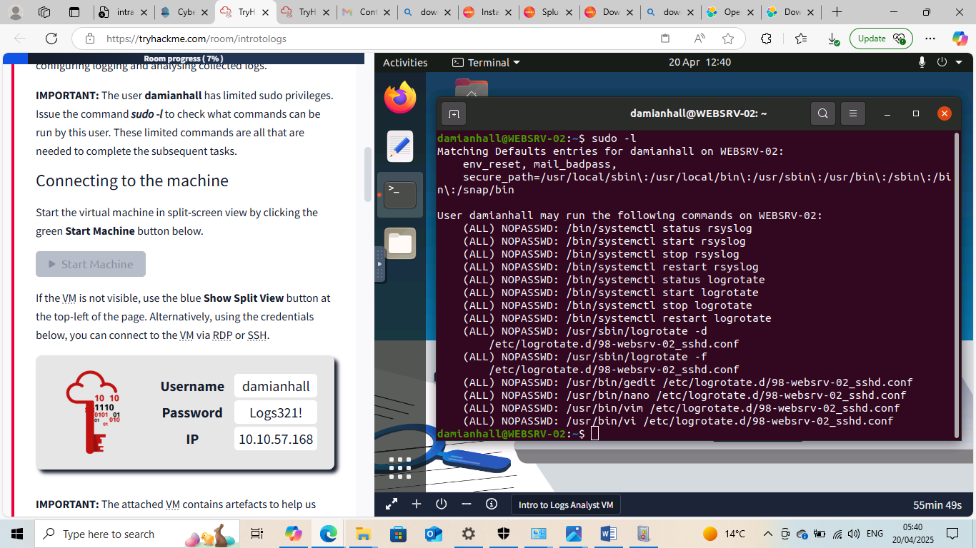

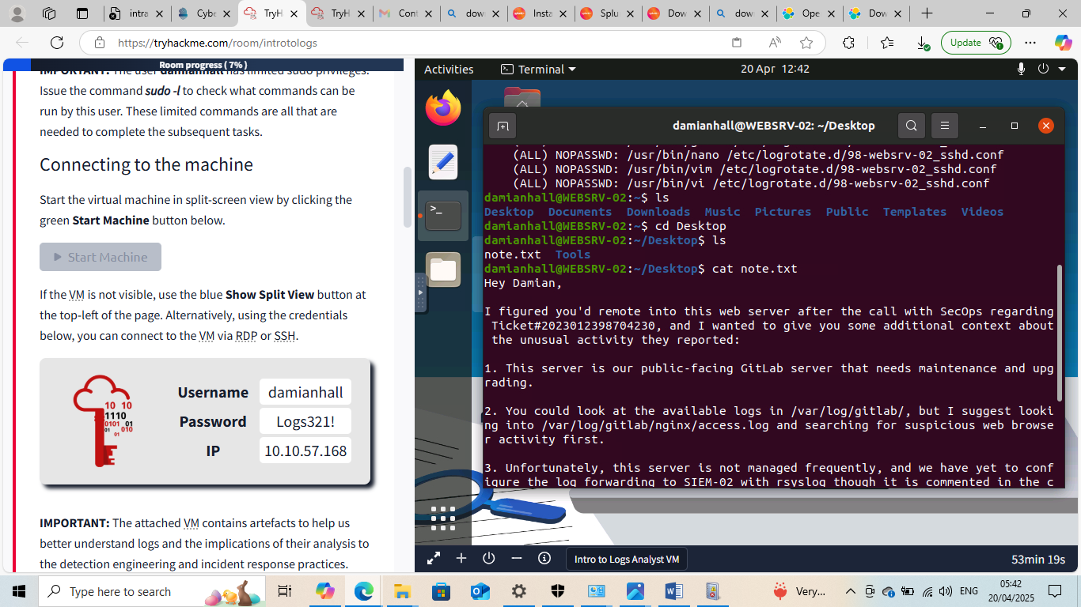

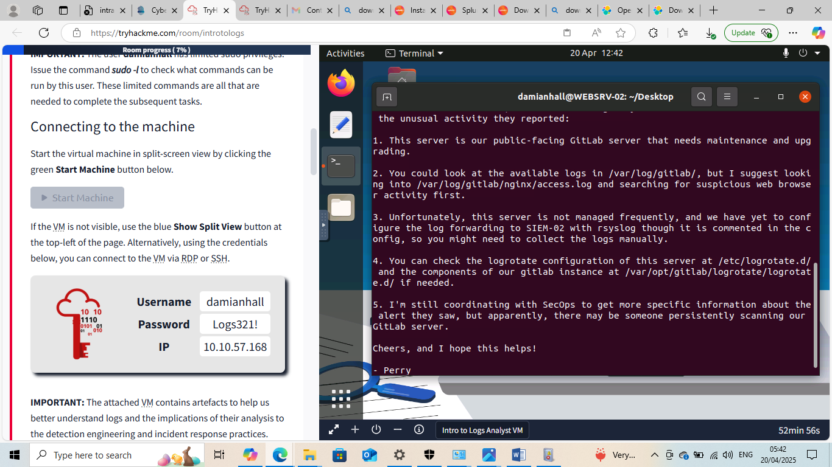

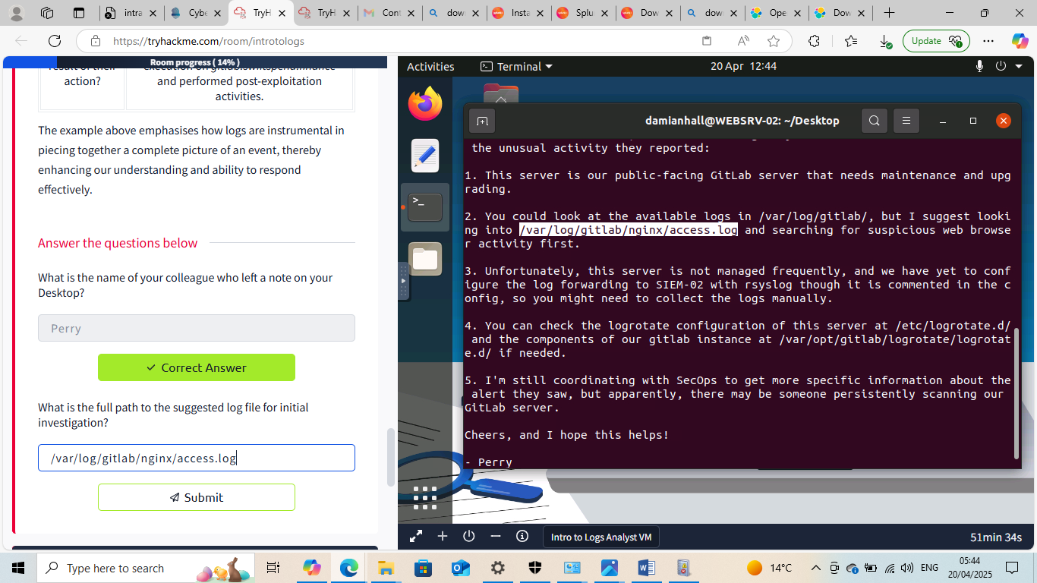

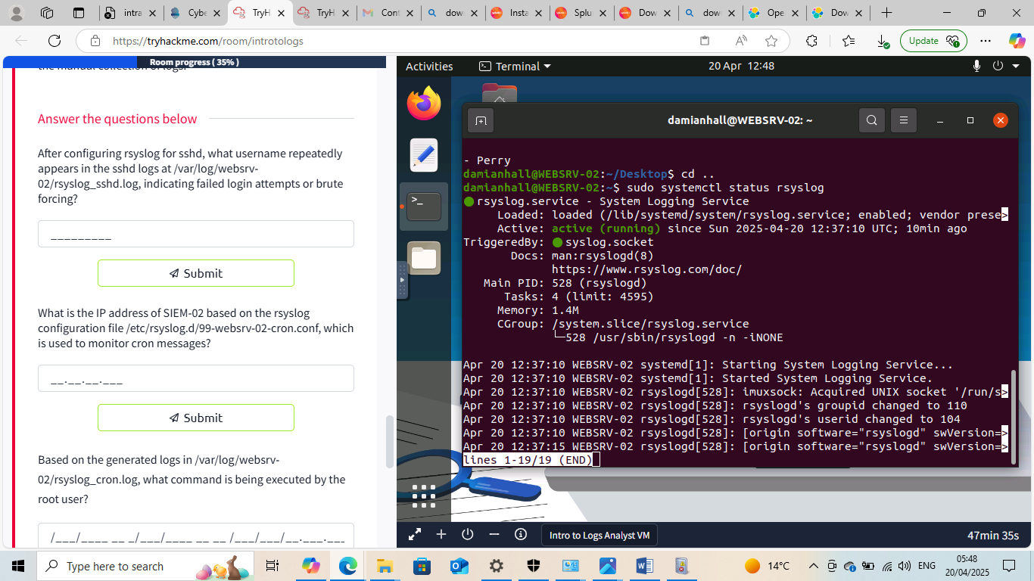





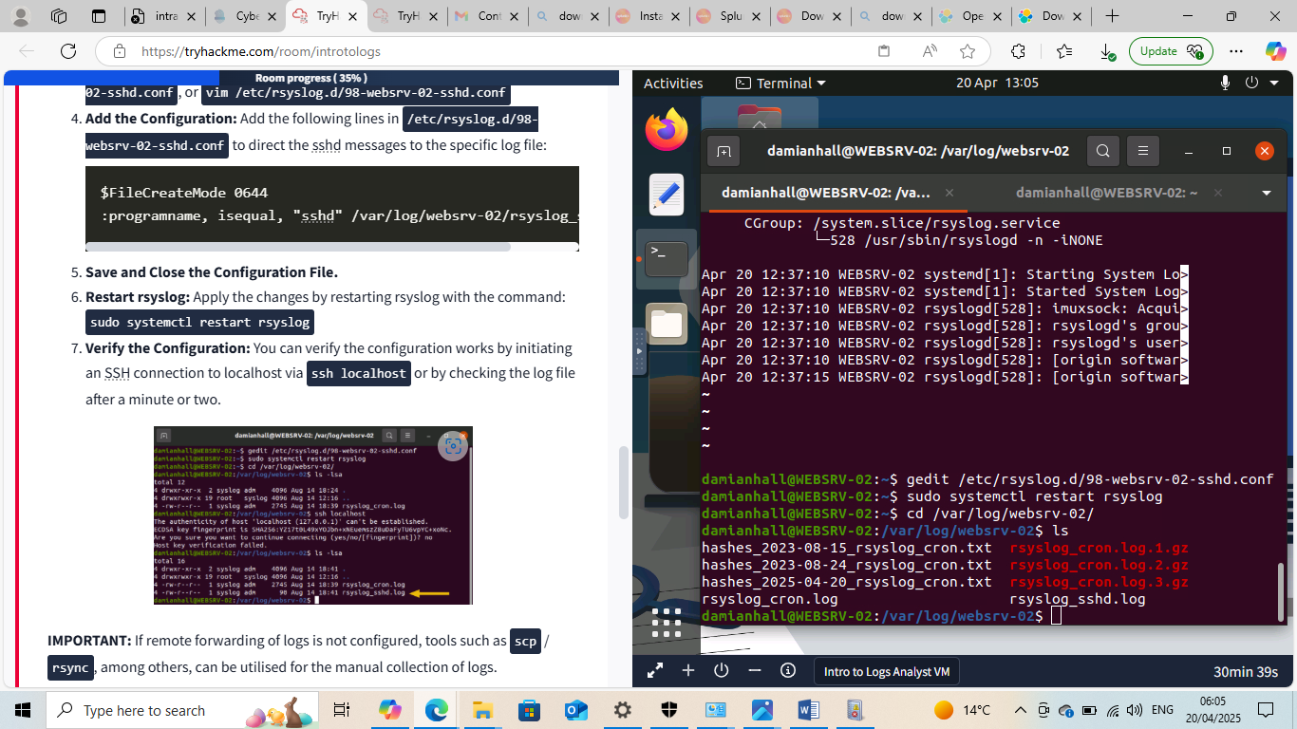
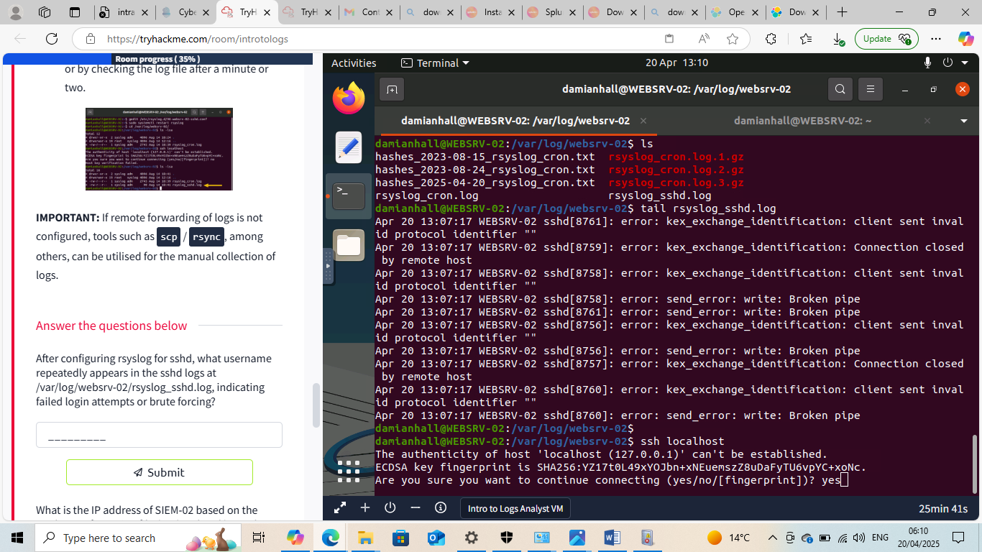

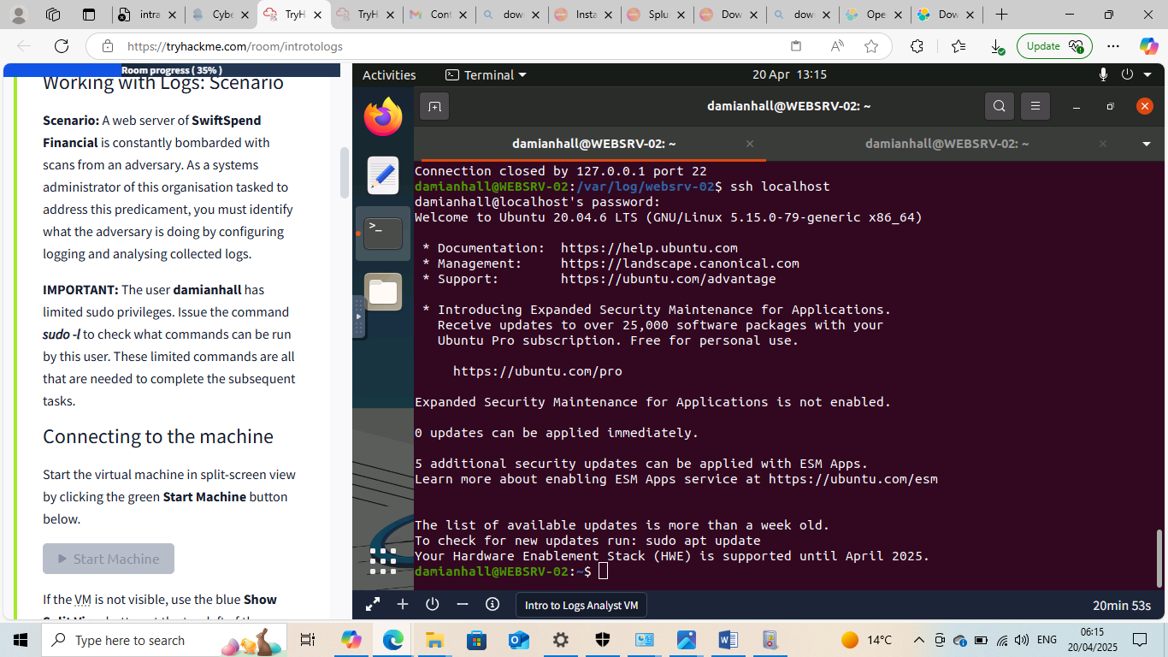

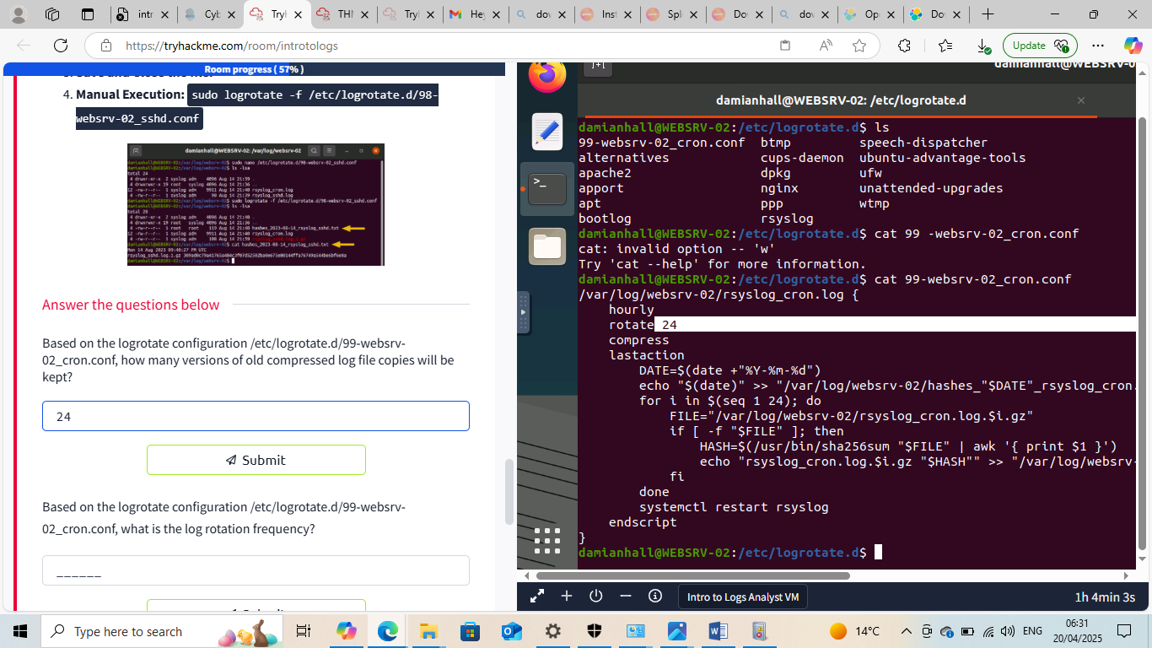

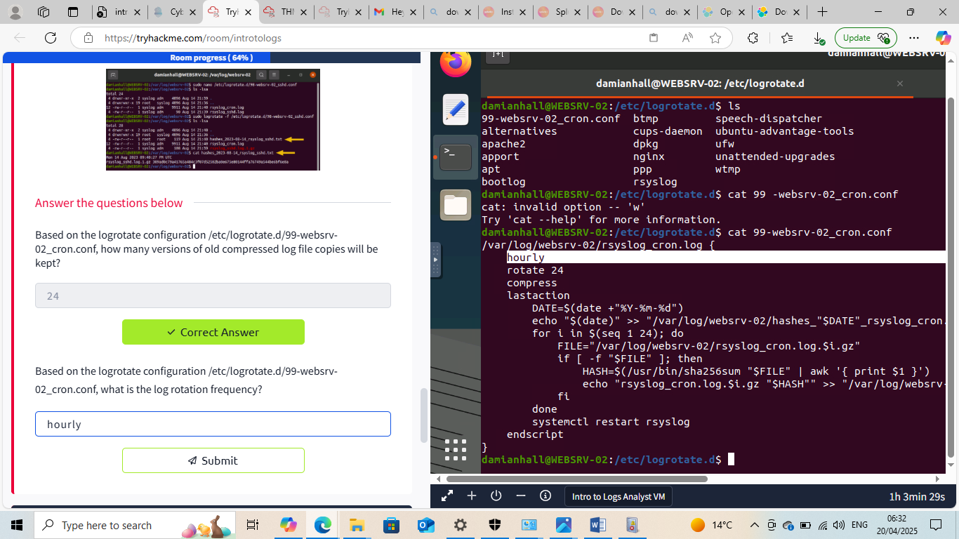



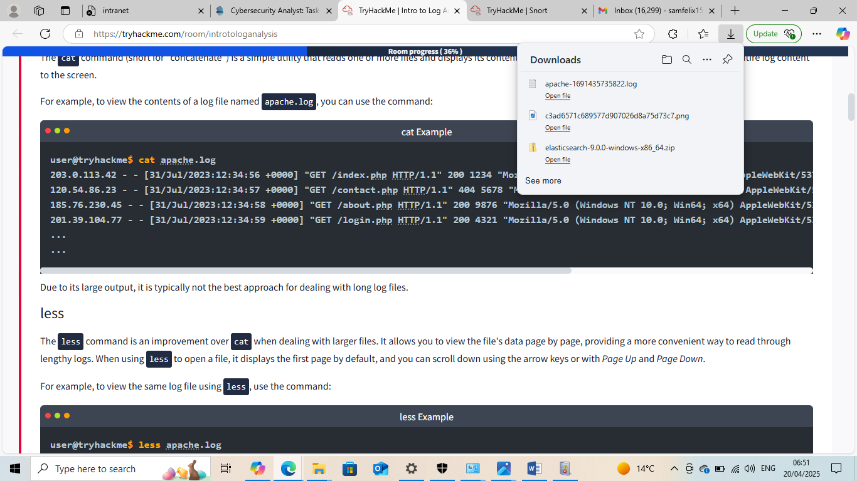

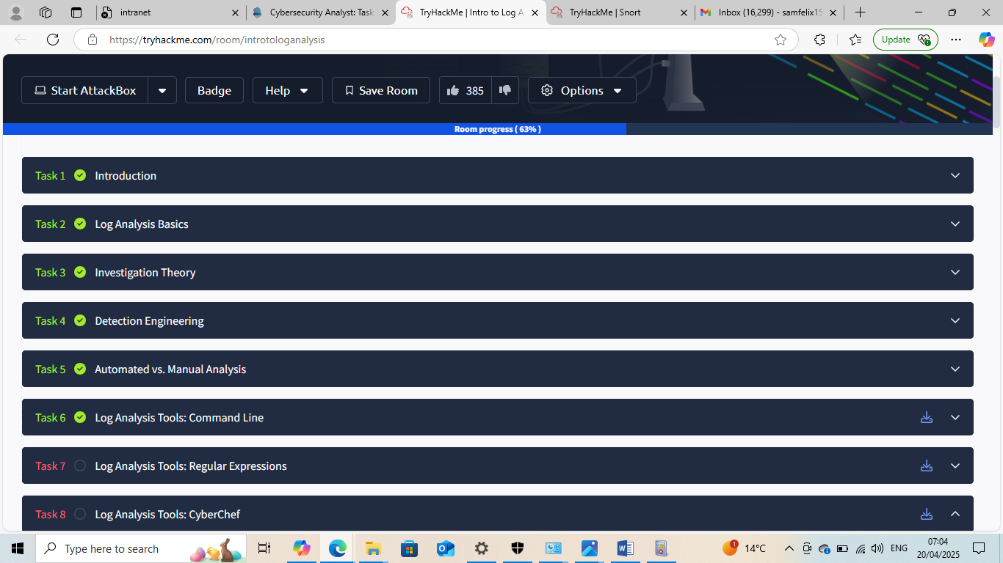
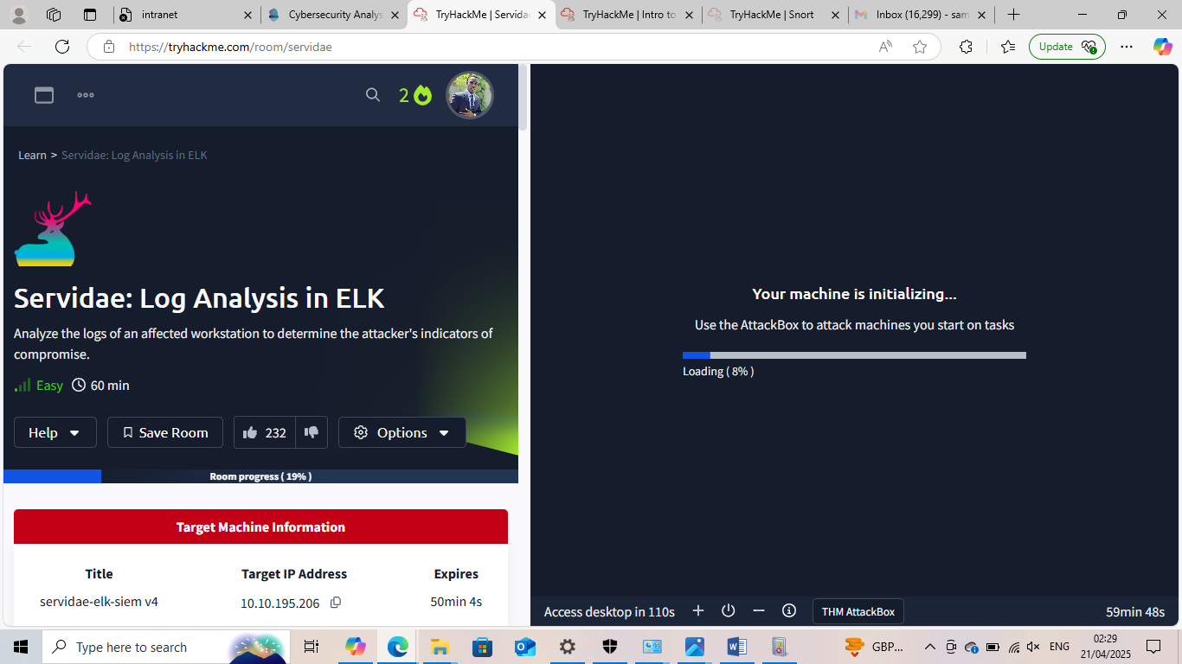

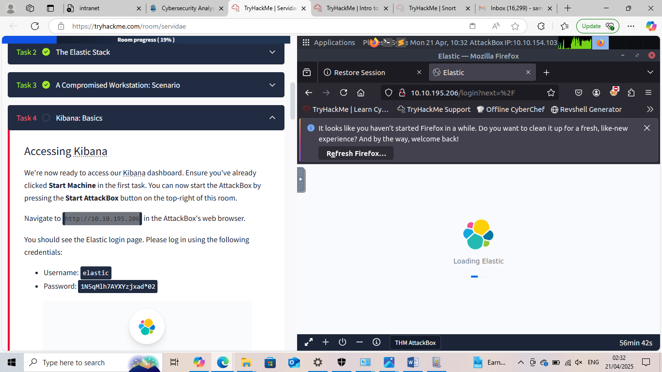



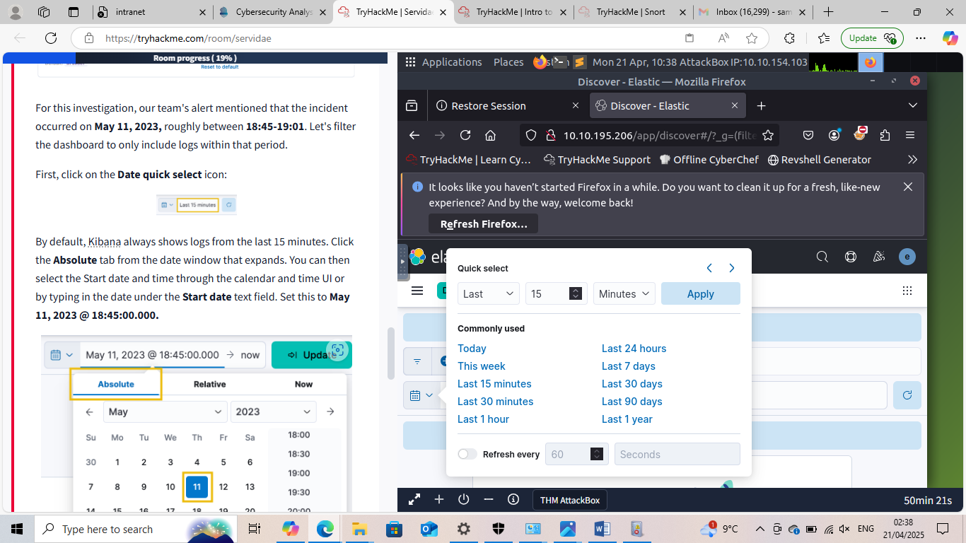

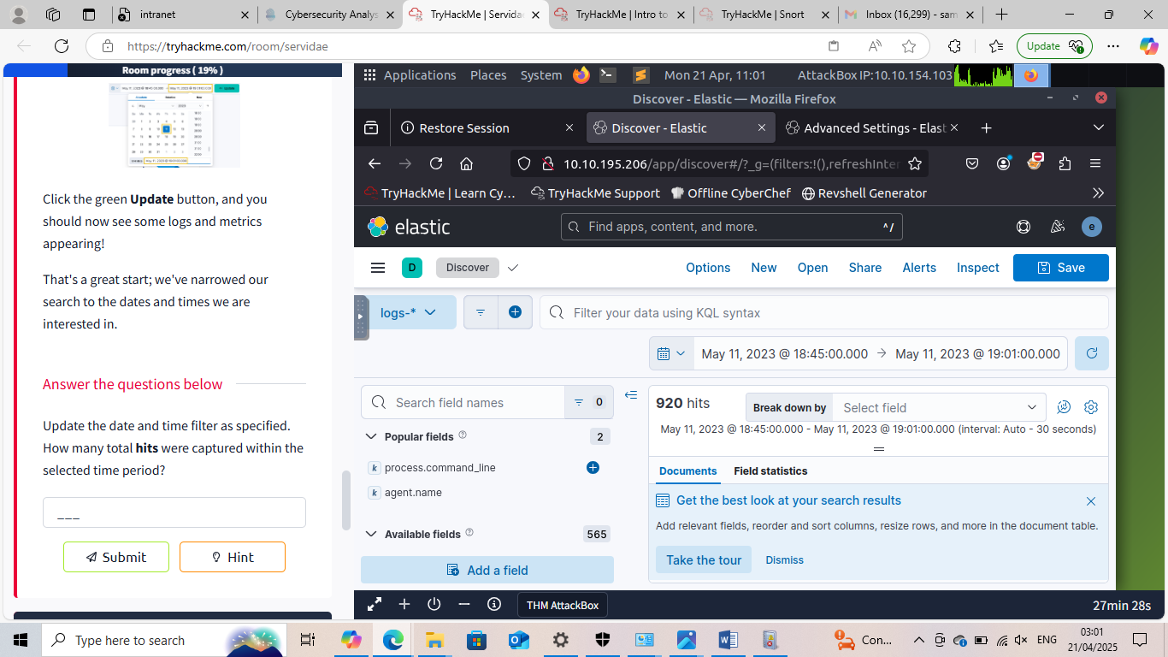
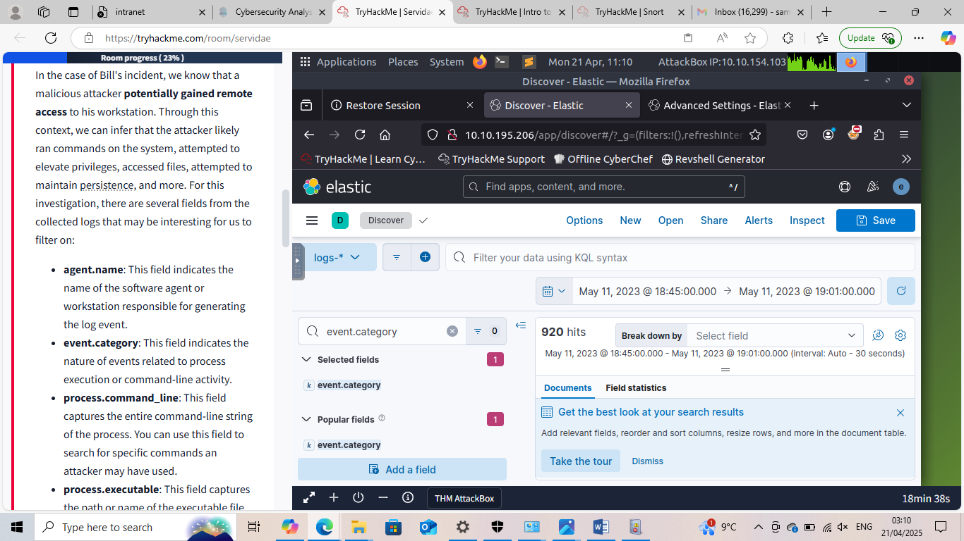

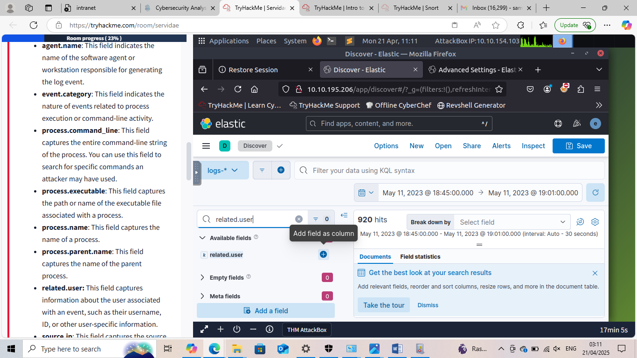

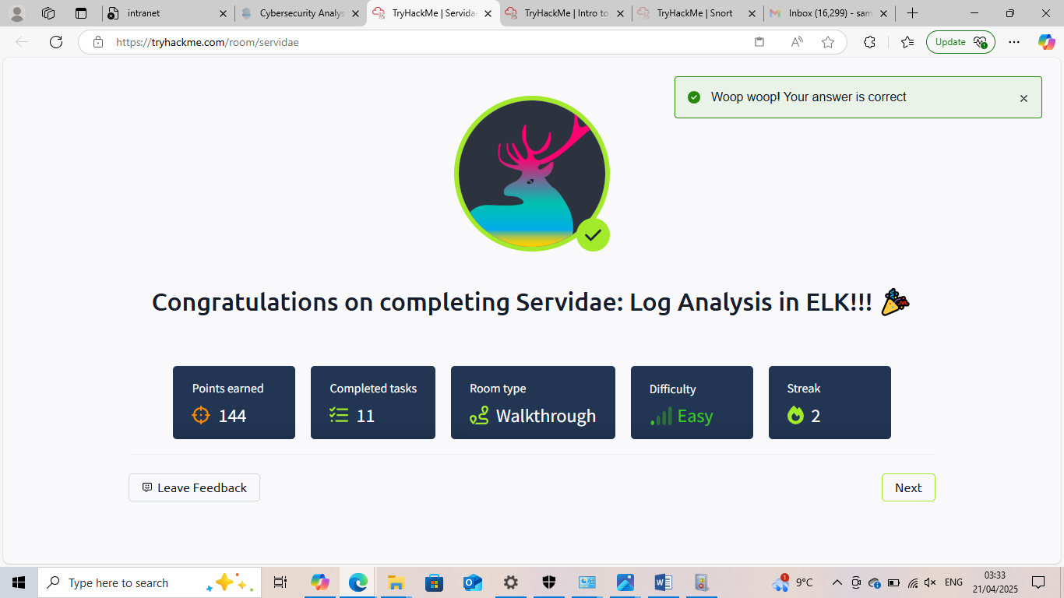

This Internship Task report was developed on [April,19, 2025]

By:
[samfelix15@gmail.com]

